
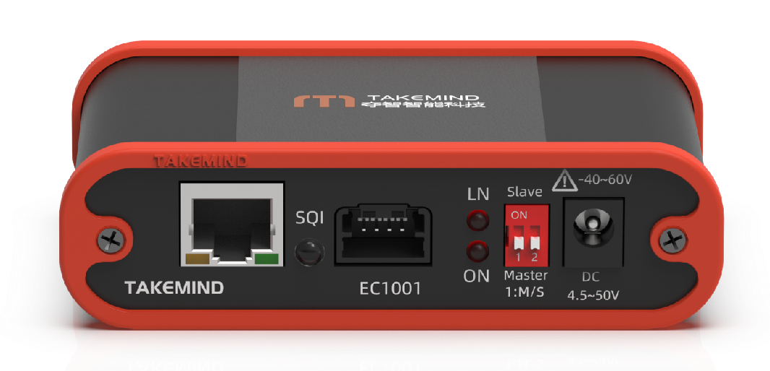

Ethernet Converter 100Mbps
www.takemind.com
manual
products
Product Manual V1.1

EC1001
100Base-T1 Ethernet Converter Introduction
The EC1001 Ethernet Converter seamlessly converts 100BASE-T1 automotive Ethernet to 100BASE-TX Fast Ethernet via an RJ45 interface. It supports bidirectional transmission in full-duplex mode, enabling reliable communication between standard computers and 100BASE-T1-based vehicle controllers.
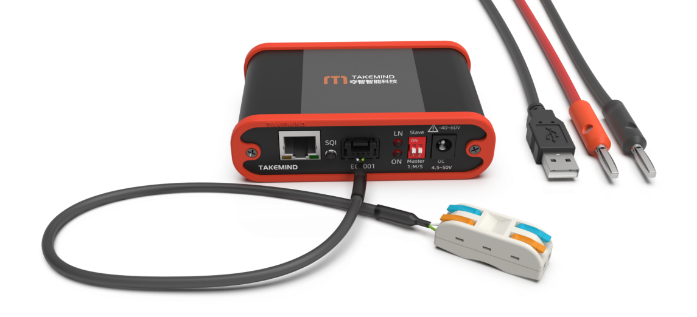

Key Features
- MOLEX Mini50 automotive Ethernet interface
- 4.5V to 50V ultra-wide voltage input, withstanding up to -40V to +60V; compatible with 12V/24V systems
- Compliant with ISO 16750-2 and ISO 7637-2 testing standards for 12V/24V vehicles, suitable for in-vehicle use
- Supports multiple power supply interfaces: USB, Banana plug, and DC 5.0
- Link LED for real-time connection status; Rainbow LED for real-time communication quality monitoring
- DIP switches for effortless configuration
- Zero data modification for lossless, transparent transmission

Product Information
Parameter | Description
Input Voltage： | 4.5~50VDC
Withstand Voltage Range: | -40~60VDC
Power Consumption： | <2W
Dimensions: | 69x104x30mm
Net Weight: | 175g
Operating Temperature: | -40℃~+80℃
Protection Rating： | IP20

Package Contents
- 1 × 100Base-T1 Ethernet Converter
- 1 × 1 m USB power cable
- 1 × 30 cm banana-plug power cable
- 1 × Mini50 connector to quick connector*
* Custom adapter cables are available upon request.

Standard Use Case
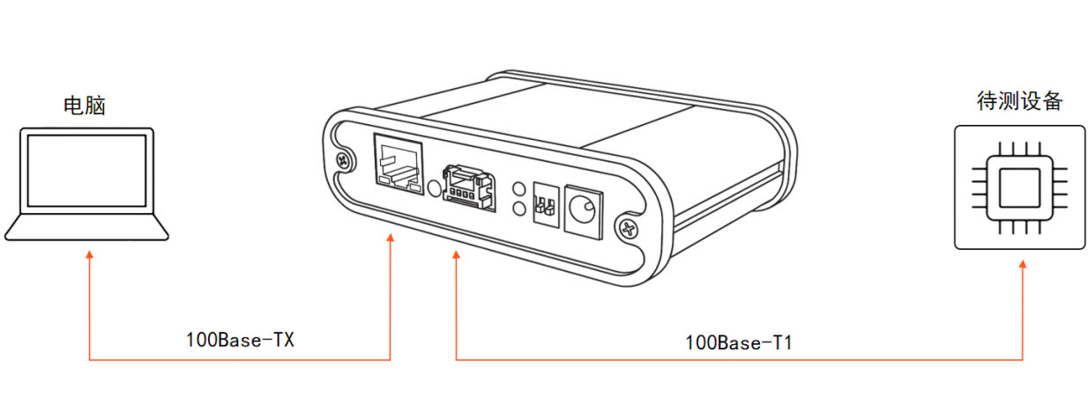
The DIP switch configuration of the EC1001 depends on the device under test.If the device under test is a master, the EC1001 must be configured as a slave.Refer to the DIP Switch section for details.

DIP Switch
DIP Switch | State | Description
1 | ON (up) | 100Base-T1 port set to Slave mode
1 | OFF (down) | 100Base-T1 port set to Master mode
2 | Reserved
Note: In a 100Base-T1 link, one device must be configured as the master and the other as the slave. The 100Base-TX interface uses auto-negotiation.

LED Information
Functional Domain | Indicator | State | Color | Description
100Base-T1 | ON | Steady on | Red | Power connected
100Base-T1 | ON | Off | — | Power not connected
100Base-T1 | LN | Steady on | Red | 100Base-T1 link established
100Base-T1 | LN | Blinking | Red | 100Base-T1 communication
100Base-T1 | LN | Off | — | 100Base-T1 link not established
100Base-T1 | SQI | Steady on | Multicolor | Signal quality;Lower value indicates poorer signal (Red, Orange, Yellow, Green, Cyan, Blue, Purple: 1–7)
100Base-T1 | SQI | Off | — | No signal
100Base-T1 | SQI | Blinking | Red | Functional error
100Base-TX | RJ45 Left | Steady on | Green | 100Base-TX link established
100Base-TX | RJ45 Left | Off | — | 100Base-TX link not established
100Base-TX | RJ45 Left | Blinking | Green | 100Base-TX communication
100Base-TX | RJ45 Right | — | — | Reserved

Application Scenarios
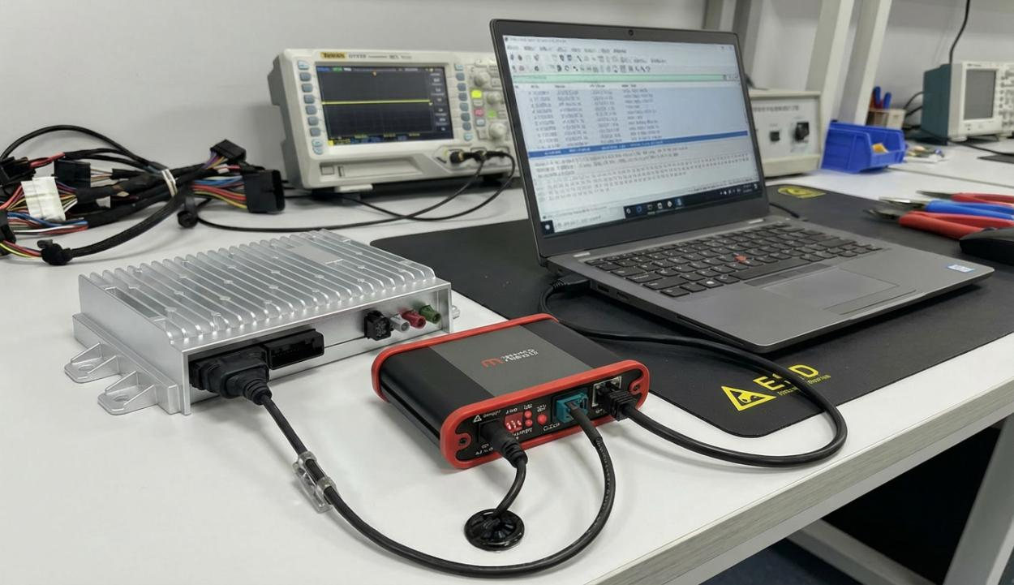
Scenario 1: Laboratory ECU Communication Debugging
This scenario demonstrates a typical connection between a vehicle controller and a host computer in a laboratory setting. The EC series device acts as a communication interface node, establishing a stable data exchange link between the controller and the PC via cables. Engineers can monitor, debug, and verify functions on the computer, ensuring the reliability and consistency of the communication process.

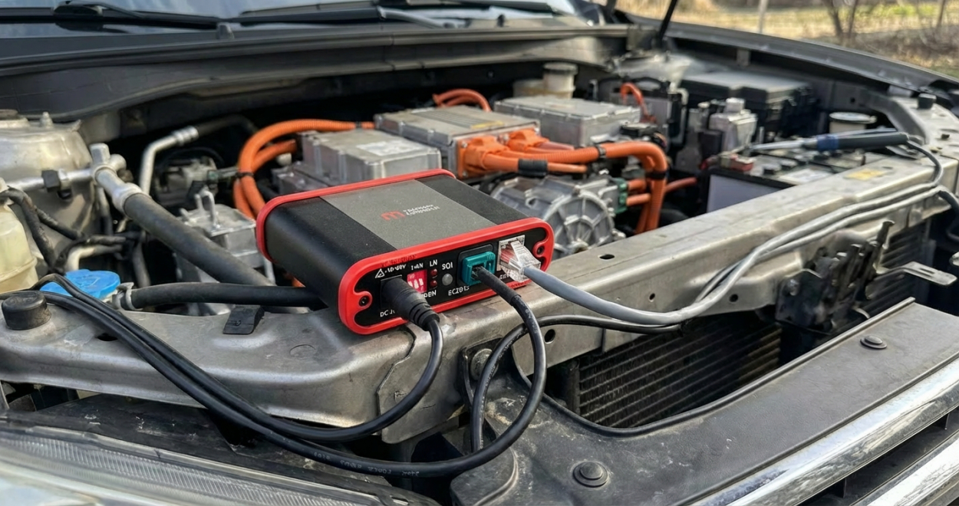
Scenario 2: In-Vehicle Environmental Debugging
This scenario showcases the application in an actual vehicle environment. The EC series interface device connects to the vehicle's ECU through an Automotive Ethernet port, enabling high-speed communication with external test systems. Used directly on the vehicle, it handles data access and transmission, supporting engineers in performing network debugging, data acquisition, and system validation under real driving conditions. This configuration is ideal for R&D road tests, control strategy verification, and real-time vehicle network diagnostics.
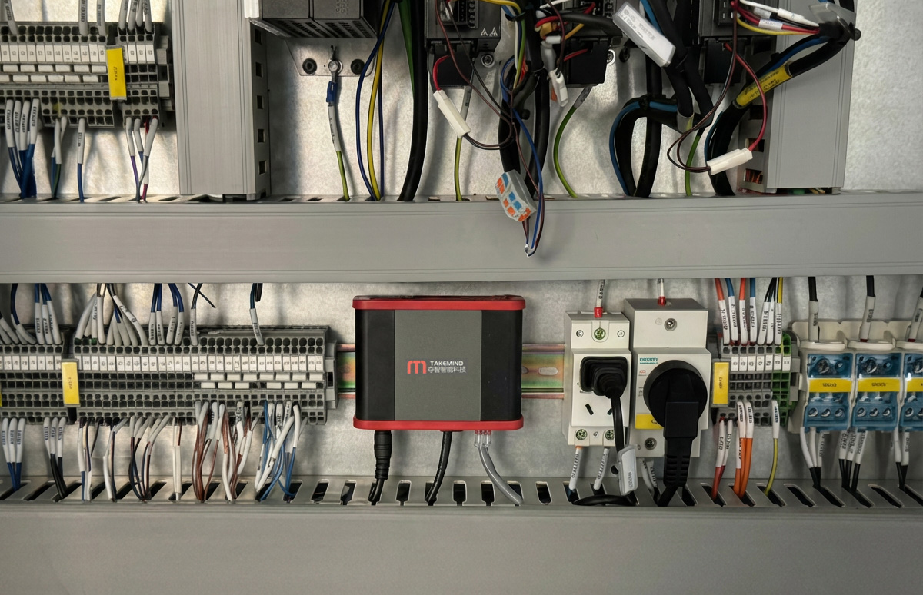
Scenario 3: Industrial Production Environment
In an industrial production control cabinet, the EC series Automotive Ethernet converter serves as a communication bridge for ECU testing. The device provides stable and reliable data conversion between Automotive Ethernet and Standard Ethernet. This configuration is widely utilized in ECU End-of-Line (EOL) testing processes.

Warranty Information
Please use this product under the conditions described in this manual.The warranty period is limited to one year. Do not disassemble the enclosure; otherwise, the warranty will be void.

Revision History
Version | Section | Description | Date
1.0 | All | Initial release | 2022/09/01
1.1 | Application Scenarios | Added application scenario description | 2025/10/21
Users can download the latest documentation for the EC1001 100Base-T1 Ethernet Converter at:
http://www.takemind.com/en/ec100x-en/

Contact Us
Shanghai Dazei Intelligent Technology Co., Ltd
Building 5, No. 288 Yulv Road, Jiading District, Shanghai, China
• +86(0)21-5997-0838
• support@takemind.com
• www.takemind.com

